Year | Mathematics Test  Angle Properties | Non Calculator Test
 | Name

Answer all questions in the spaces provided on this test paper by
Writing the answer in the box provided.
or
Shading in the bubble for the correct answer from the four choices provided.
Show any working out on the test paper.
1. | 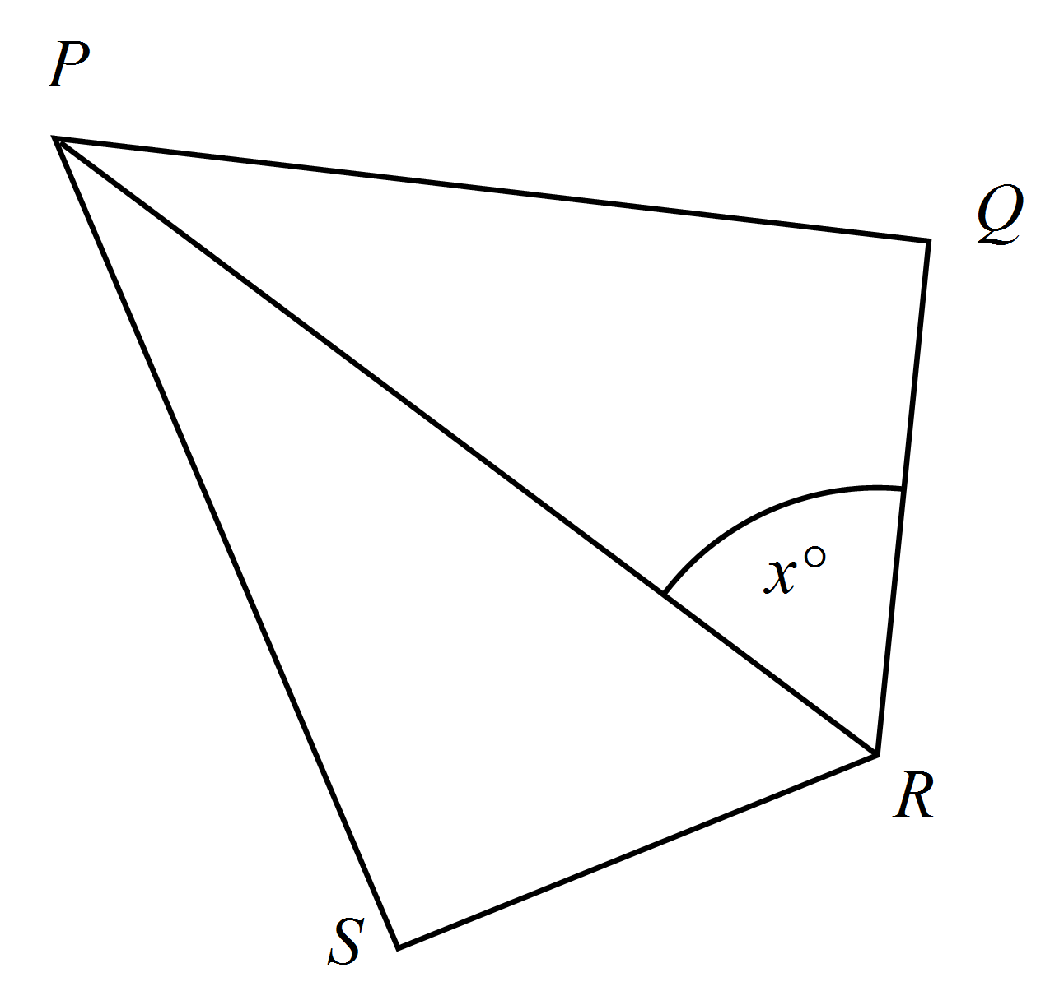The angle marked 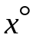could be labelled as :  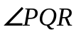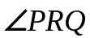  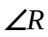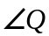
2. | Write two other ways of labelling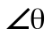.  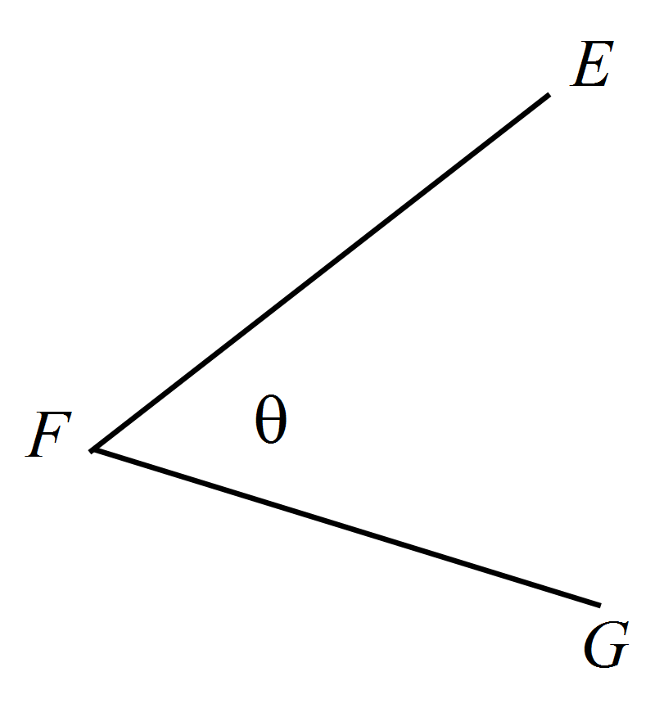  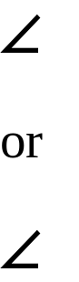
3. | 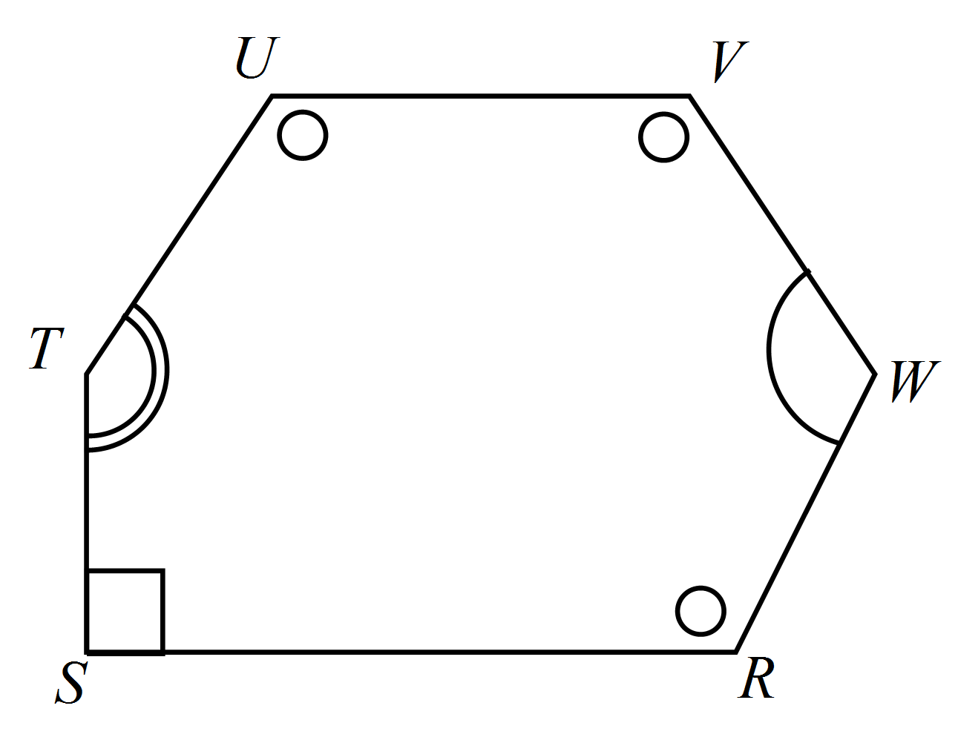Which angles are equal to  in the hexagon below?  
4. | What angle is the supplement of 78º?  o
5. | Which is true?  67º is the complement of 113º and the supplement of 23º.  67º is the complement of 33º and the supplement of 113º  67º is the complement of 23º and the supplement of 113º  67º is the complement of 113º and the supplement of 33º
6. | Complete the following to make a correct statement.  An obtuse angle is any angle between º and º.
7. | In which diagram are 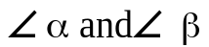 equal, complementary angles?  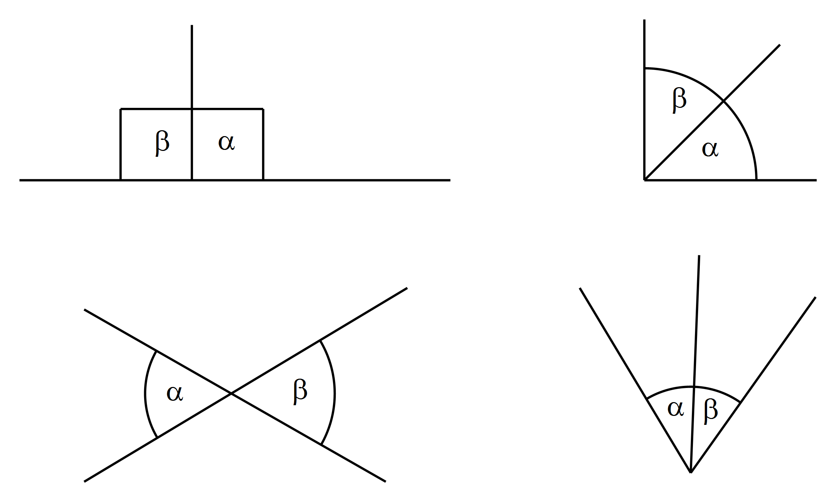
8. | 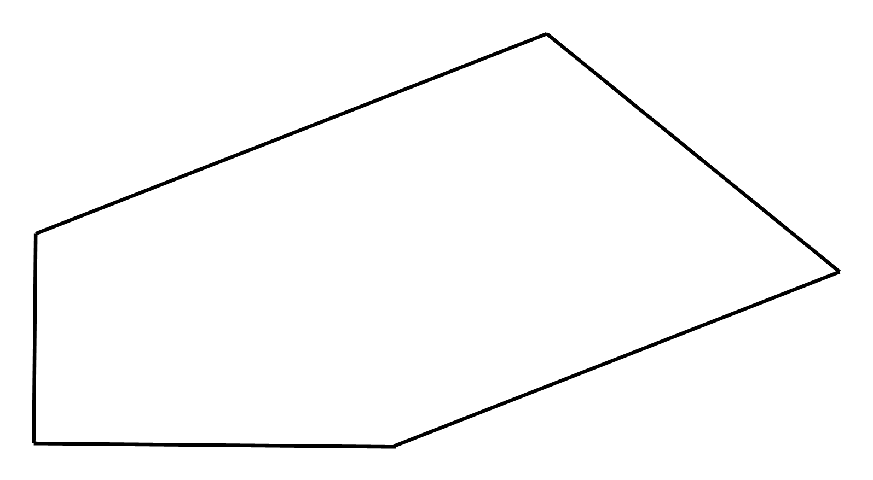Use the correct symbols to mark a pair of parallel lines and a right angle on the diagram.
9. | 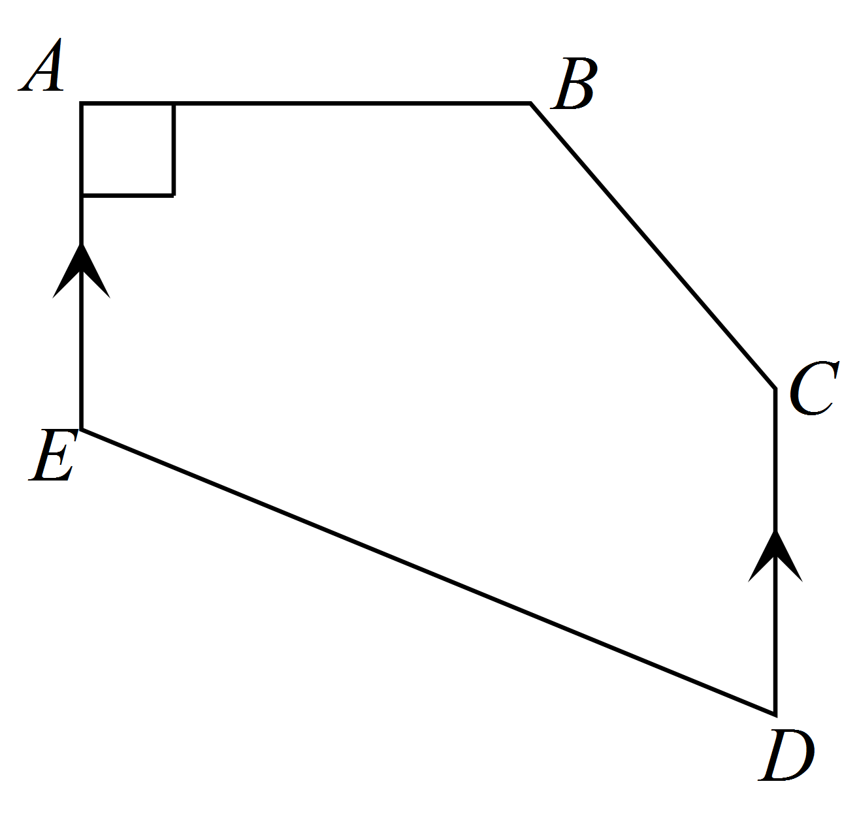Which statement is true?        
10. | Measure with a protractor and write the size of 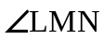on the diagram.  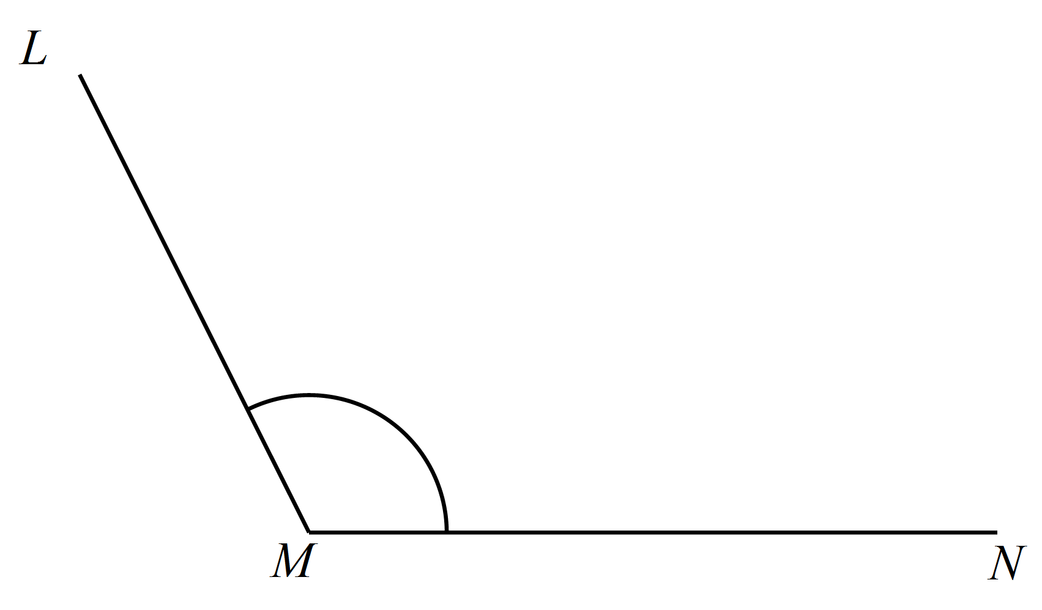
11. | 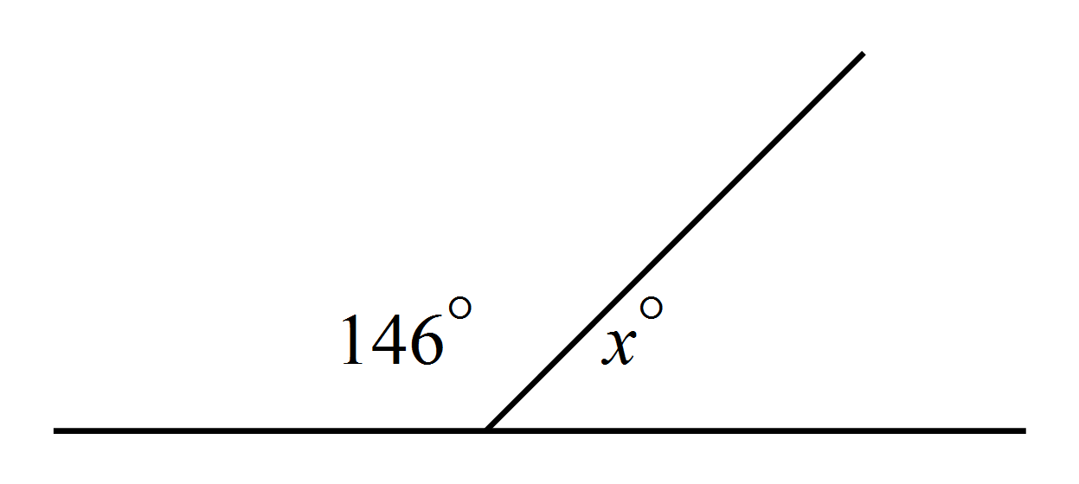Find the value of x.  x =
12. | 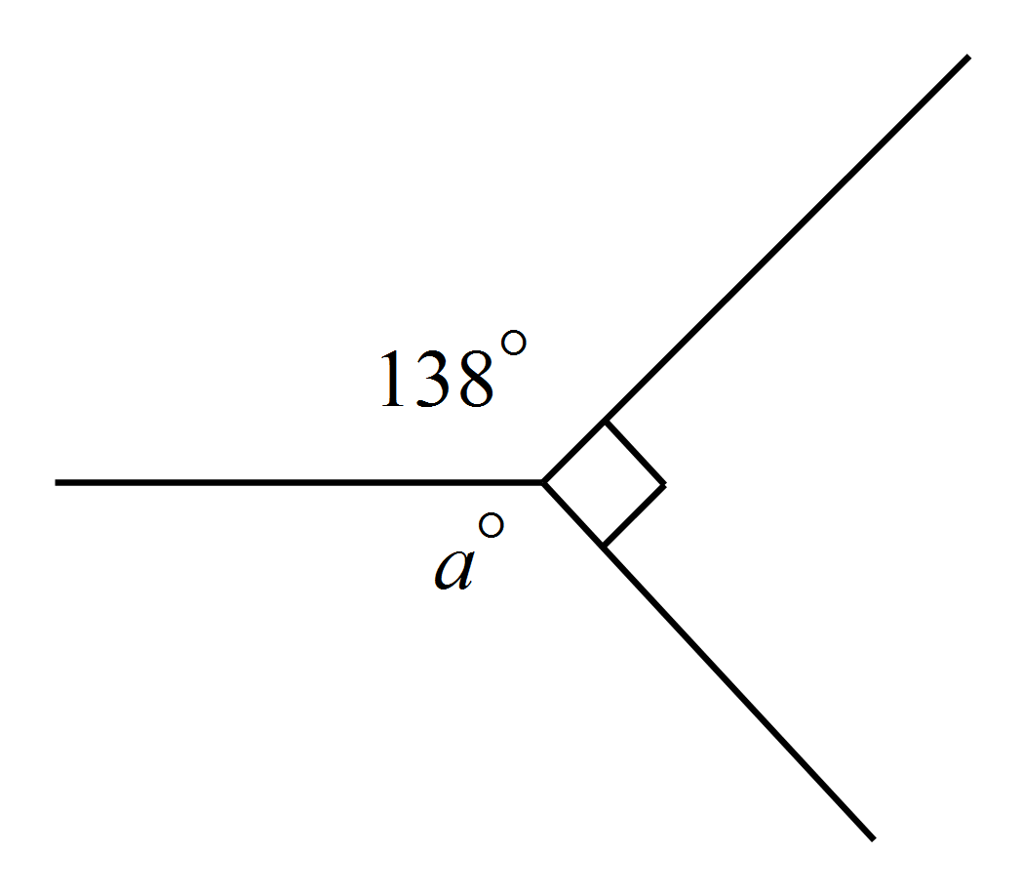 a =?  138º  122º  48º  132º
13. | 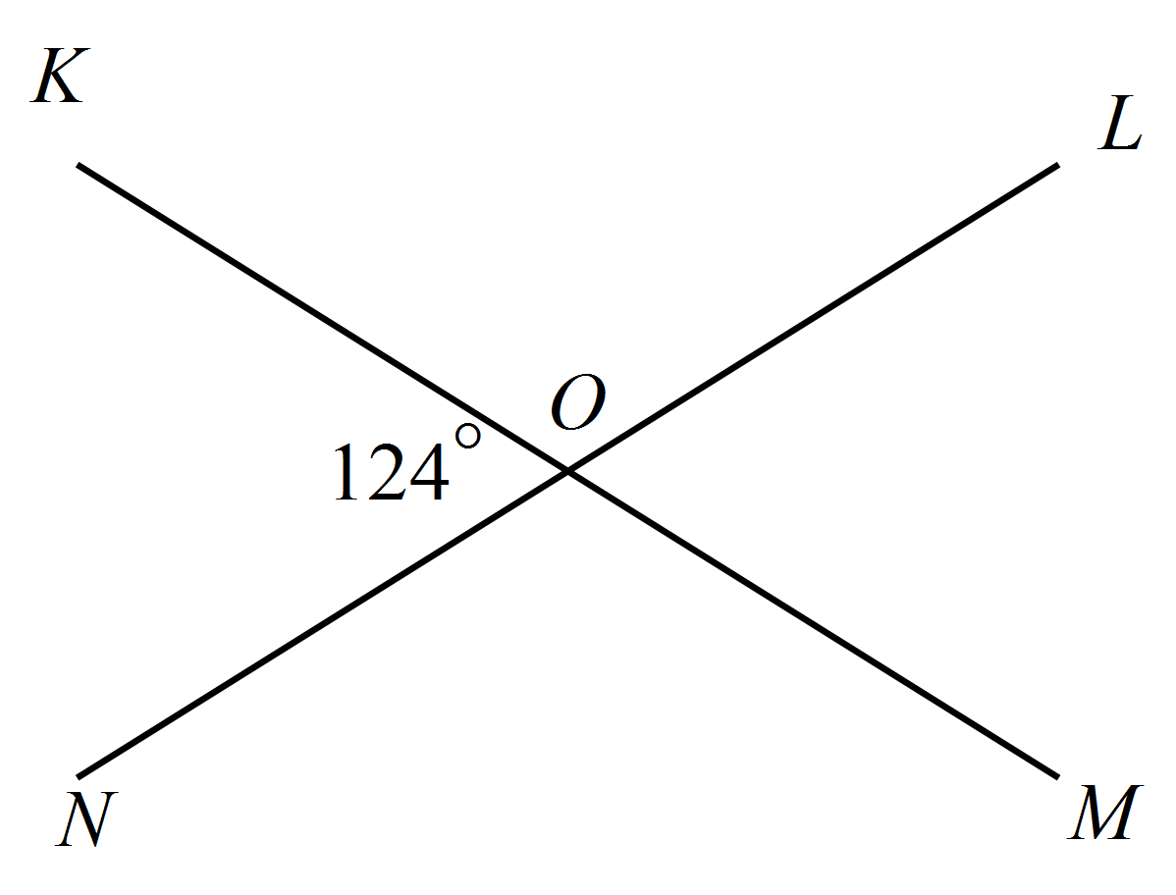Find the size of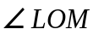.  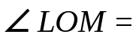
14. | 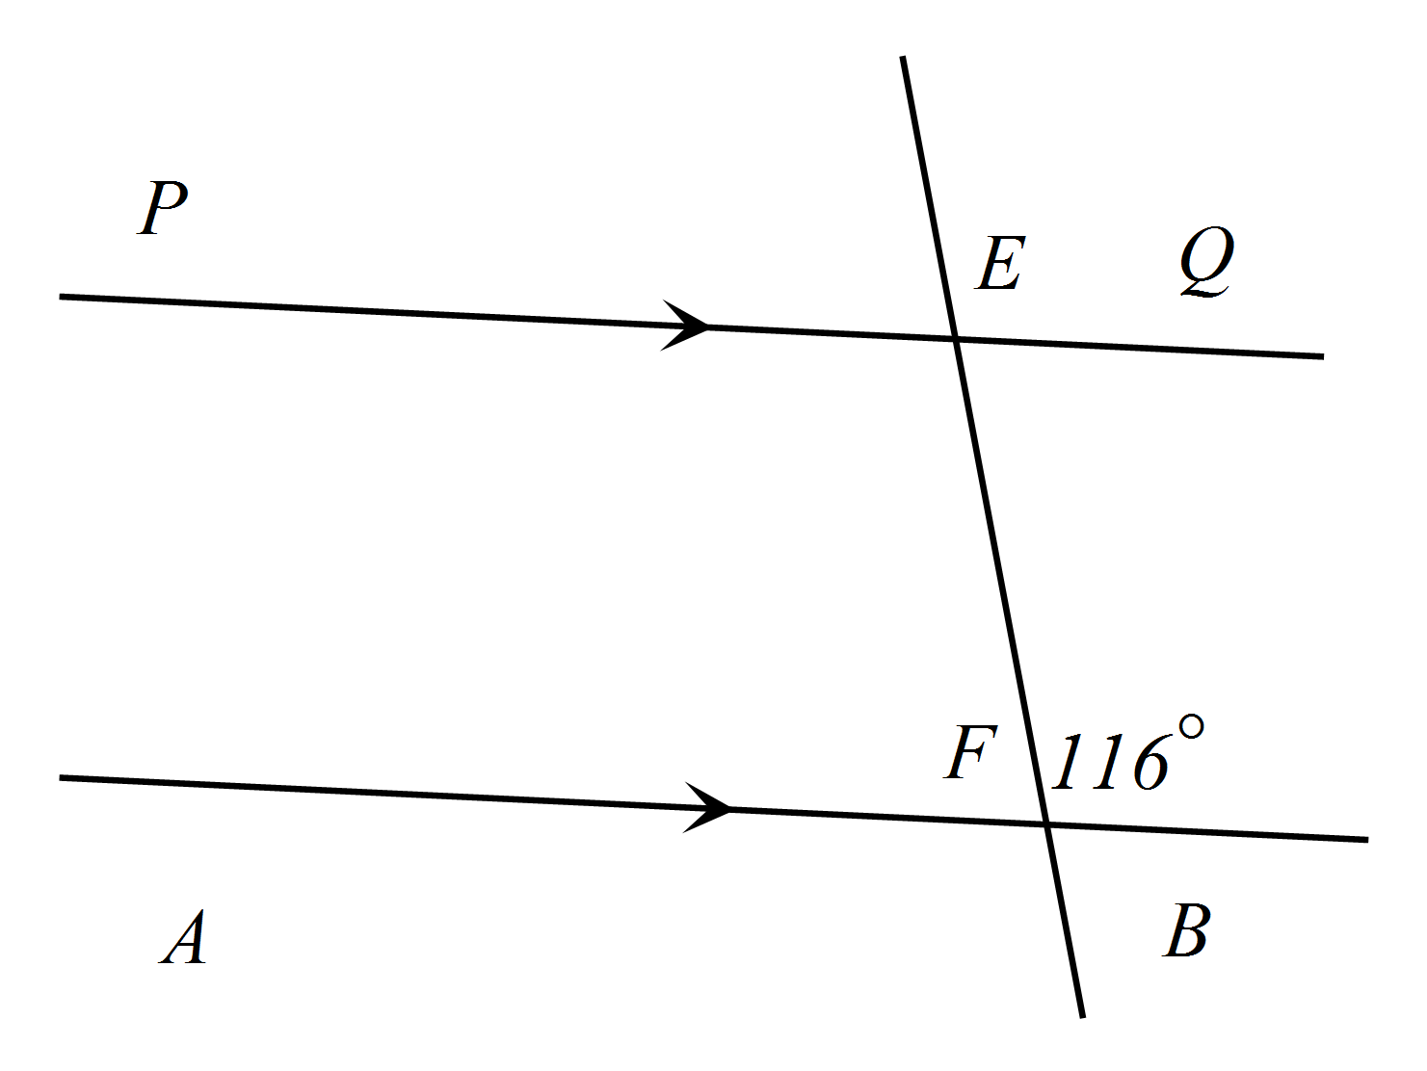 .  Find the size of 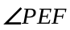.  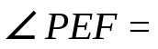
15. | 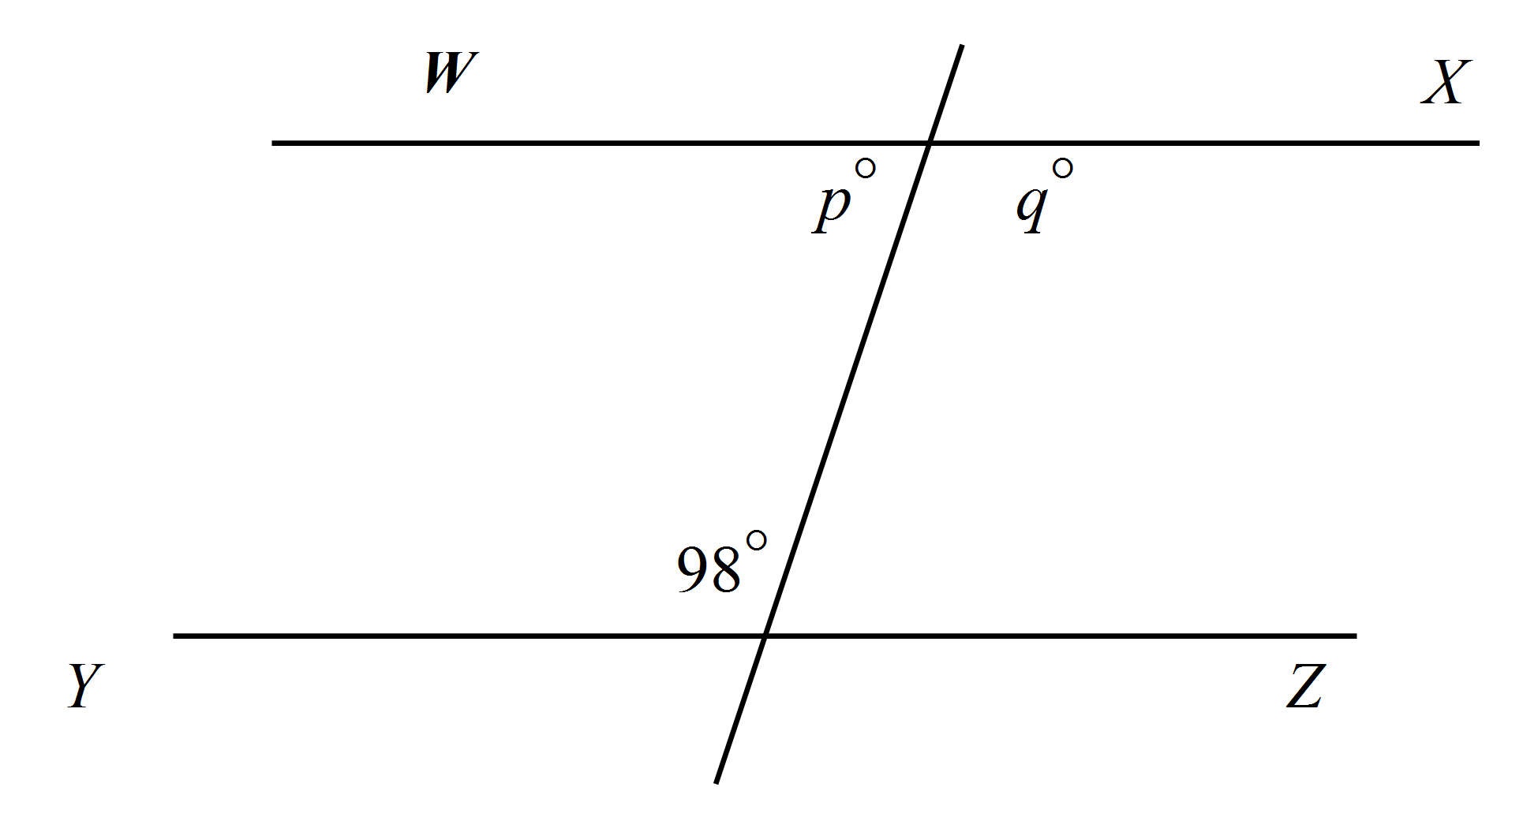The lines WX and YZ are parallel.  Which is true?  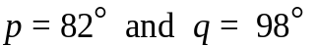  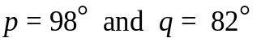  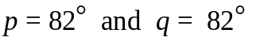  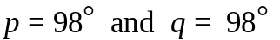
16. | 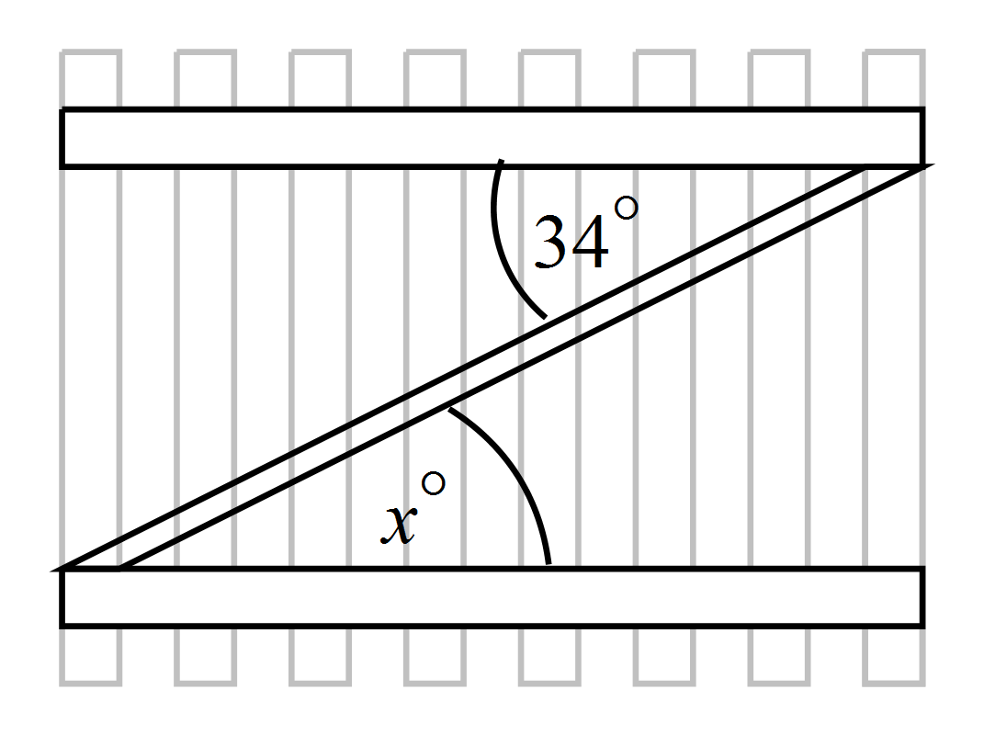A brace is placed across a gate as shown.  What is the value of x?  34º  56º  146º  226º
17. | 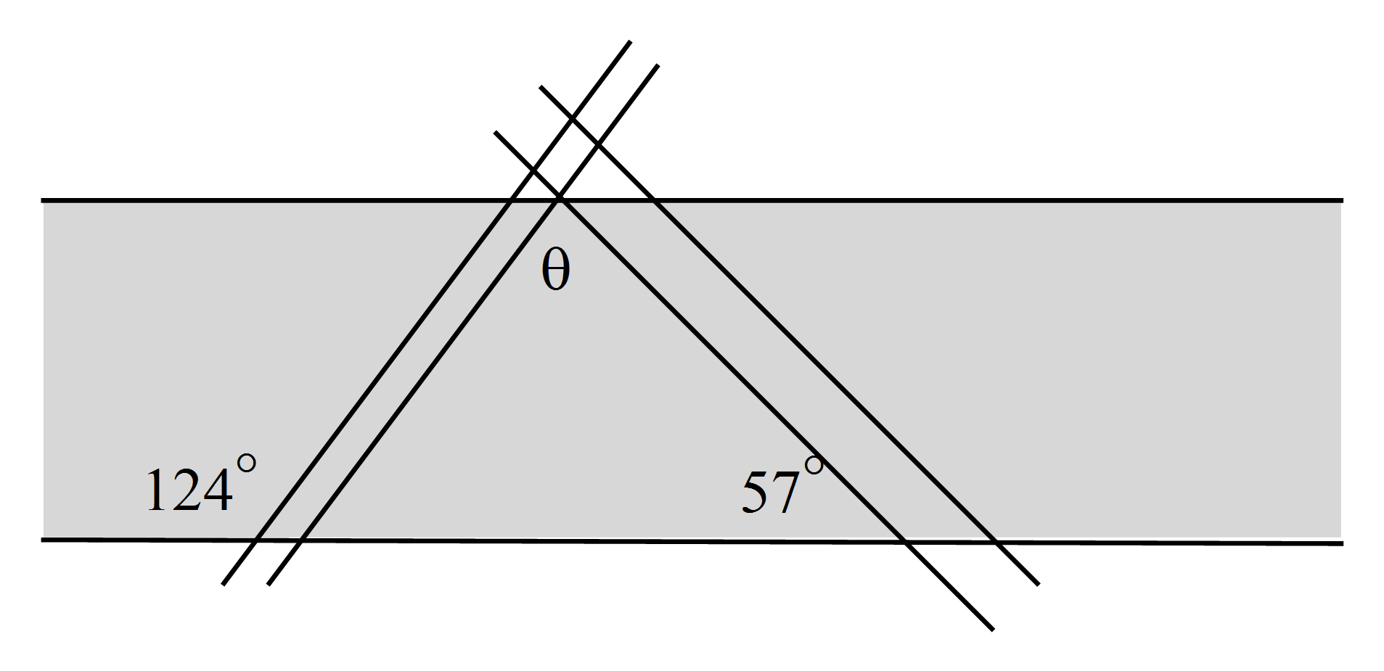Two cars have driven across a road, leaving tyre marks. What is the size of the angle ?  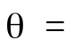
18. | 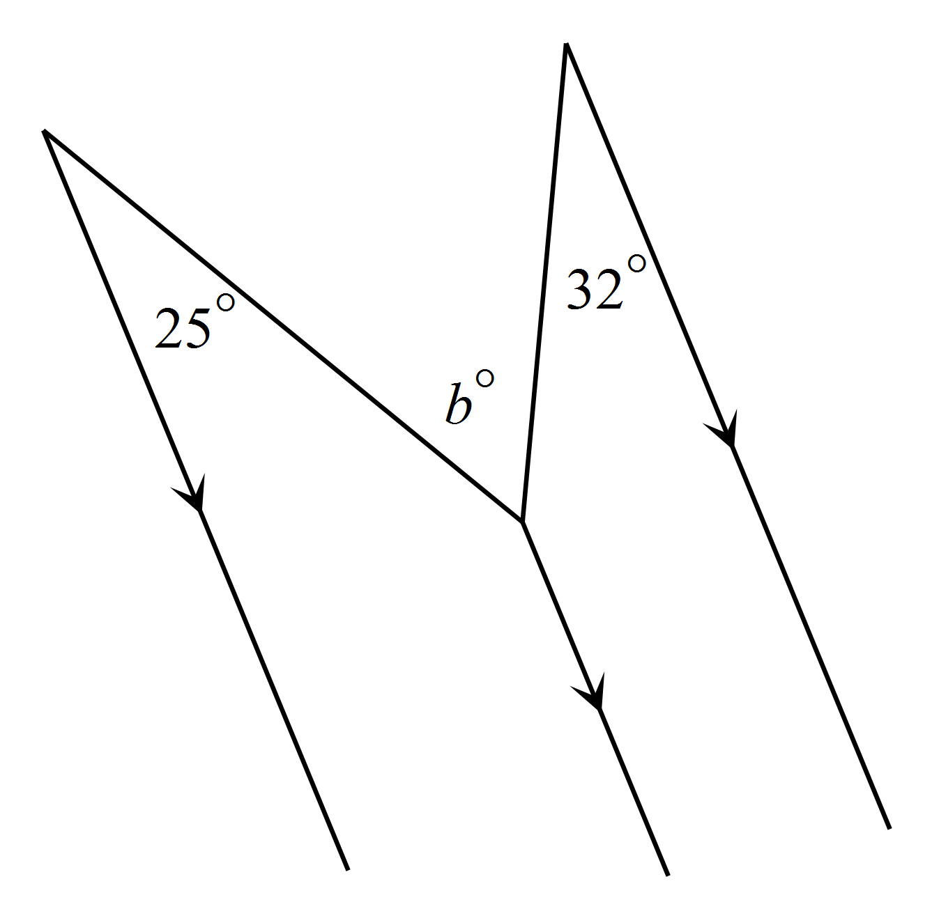Find the value of b.  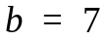  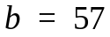  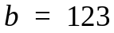  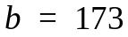
19. | 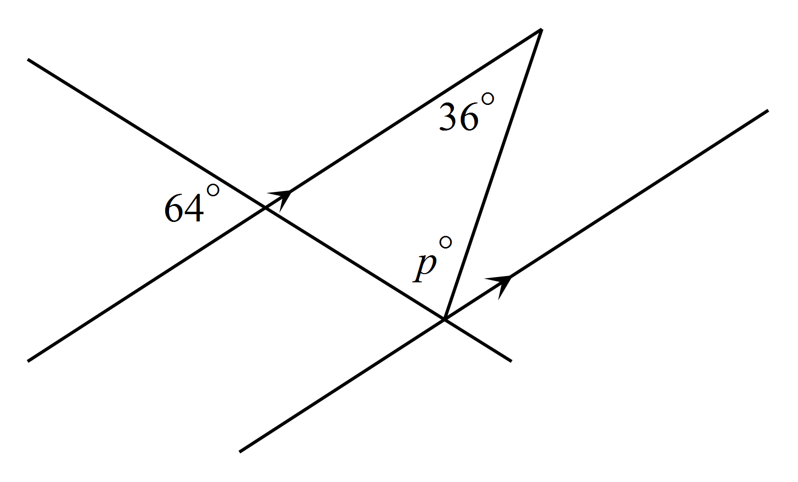Find the size of.  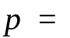
20. | Find the value of c.  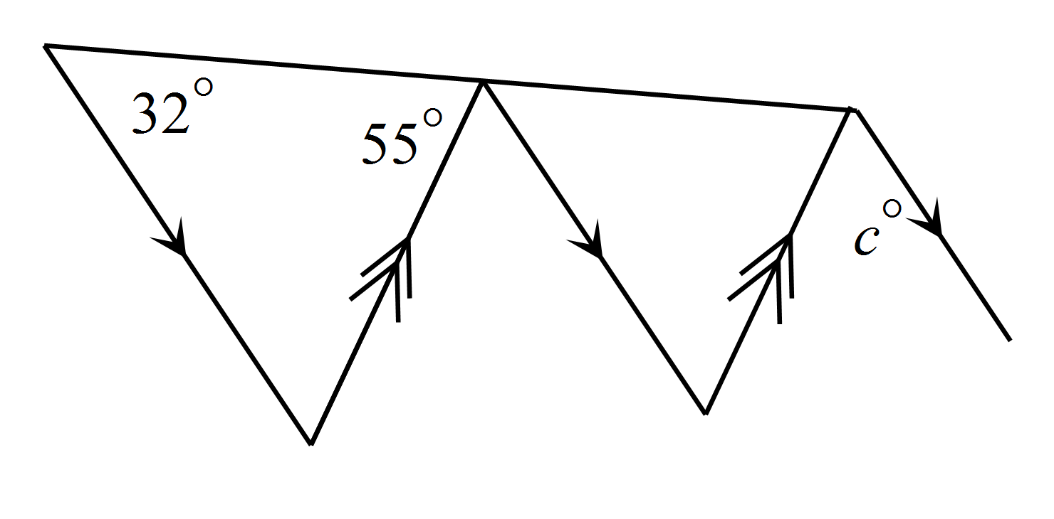  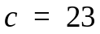  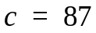  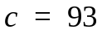  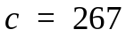
21. | 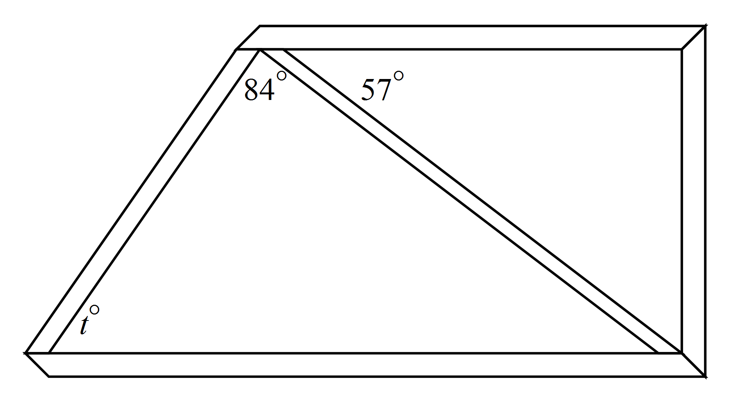A section of the frame of a  go-cart is shown. The top and bottom bars are parallel. Find the value of t.  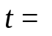
22. | 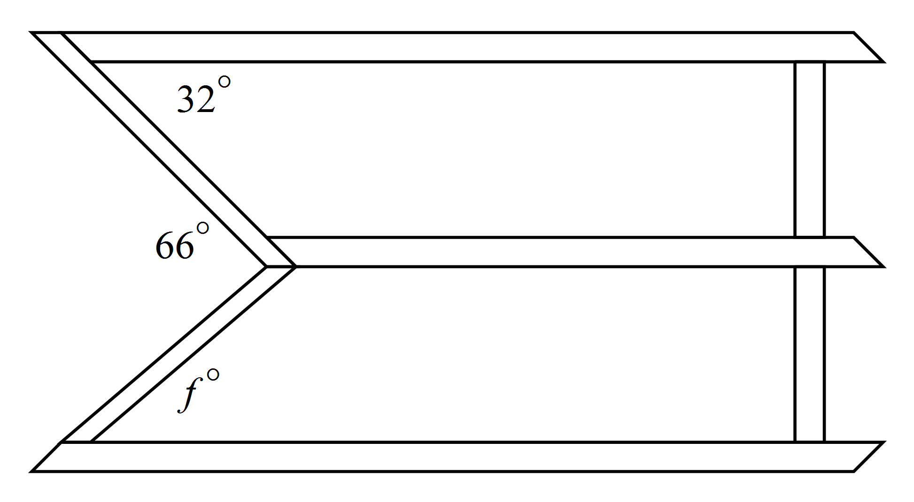A scaffold has three horizontal floors.  Ladders join the floors at the angles shown.  What is the value of f.  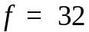  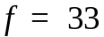  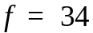  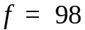

Year |  | Mathematics Test  Angle Properties | Non Calculator Test
 |  | ANSWERS
Answer all questions in the spaces provided on this test paper by
Writing the answer in the box provided.
or
Shading in the bubble for the correct answer from the four choices provided.
Show any working out on the test paper.
1. | The angle marked could be labelled as :
2. | Write two other ways of labelling.  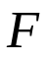  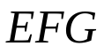
3. | Which angles are equal to in the hexagon below?  TUV  WRS  
4. | What angle is the supplement of 78º?  o  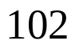
5. | Which is true?  67º is the complement of 113º and the supplement of 23º.  67º is the complement of 33º and the supplement of 113º  67º is the complement of 23º and the supplement of 113º  67º is the complement of 113º and the supplement of 33º
6. | Complete the following to make a correct statement.  90  180  An obtuse angle is any angle between º and º.
7. | In which diagram are equal, complementary angles?
8. | 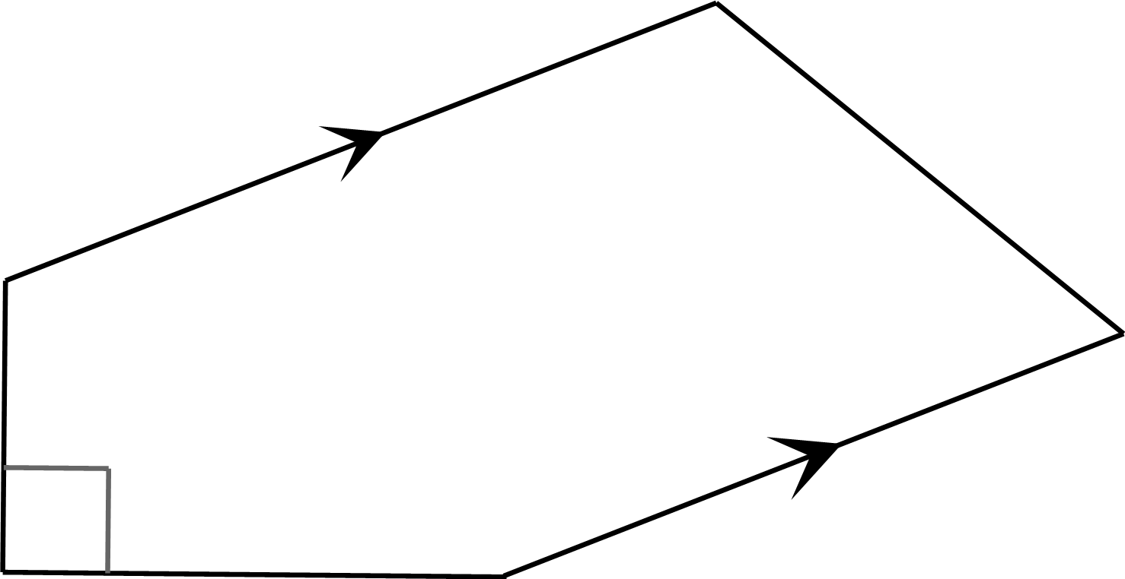Use the correct symbols to mark a pair of parallel lines and a right angle on the diagram.
9. | Which statement is true?
10. | Measure with a protractor and write the size of on the diagram.  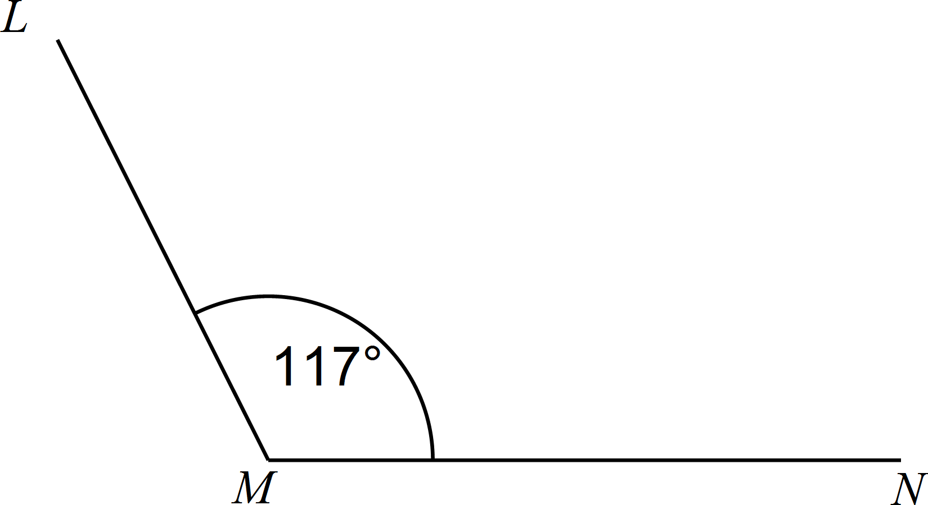  Allow for 2 degrees error in measurement.
11. | Find the value of x.  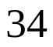  x =
12. | aº =?  138º  122º  48º  132º
13. | Find the size of.  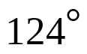
14. | .  Find the size of .  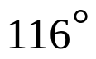
15. | The lines WX and YZ are parallel.  Which is true?
16. | A brace is placed across a gate as shown.  What is the value of x?  34º  56º  146º  226º
17. | Two cars have driven across a road, leaving tyre marks. What is the size of the angle ?  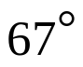
18. | Find the value of b.
19. | Find the size of.  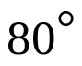
20. | Find the value of c.
21. | A section of the frame of a  go-cart is shown. The top and bottom bars are parallel. Find the value of t.  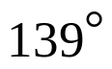
22. | A scaffold has three horizontal floors.  Ladders join the floors at the angles shown.  What is the value of f.

